Heavy-duty pressure switch for
superior applications

Klingenberg, May 2018.
From pumps, through hydraulic systems to autoclaves: WIKA's new heavy-duty pressure switch, model PSM-550, has been designed for superior industrial applications.

The new instrument switches electrical loads up to AC 230 V / 10 A with a non-repeatability of the switch point of ≤ 1 %. The high accuracy ensures that the machine operates optimally and, through that, also safeguards the quality of the manufactured products.

The pressure switch can be delivered both with setting ranges for gauge pressure (0 … 300 mbar to 10 … 30 bar) and with vacuum setting ranges (-1 … 0 bar and -0.8 … +5 bar).
It is thus also suitable for monitoring vacuum circuits, such as with cleaning processes. The robust instrument has an ingress protection of IP67. Furthermore, there is a PSM-550 in a version for medium temperatures up to 170 °C, which has wetted parts from stainless steel.

Number of characters: 869
Key word: PSM-550

Manufacturer:
WIKA Alexander Wiegand SE & Co. KG
Alexander-Wiegand-Straße 30
63911 Klingenberg/Germany
Tel. +49 9372 132-0
Fax +49 9372 132-406
vertrieb@wika.com
www.wika.de
WIKA company photograph:
Pressure switch model PSM-550

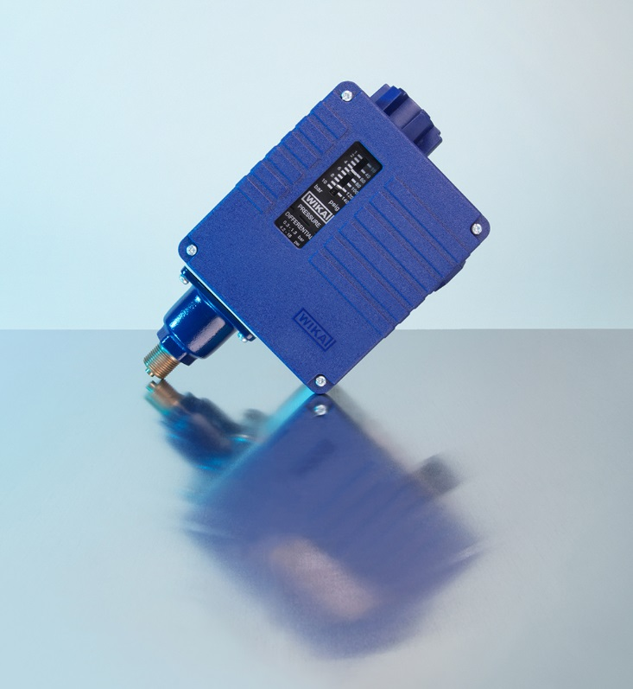

Edited by:
WIKA Alexander Wiegand SE & Co. KG
André Habel Nunes
Marketing Services
Alexander-Wiegand-Straße 30
63911 Klingenberg/Germany
Tel. +49 9372 132-8010
Fax +49 9372 132-8008010
andre.habel-nunes@wika.com
www.wika.de

WIKA press release 06/2018

