Hydrostatic level measurement:
New information platform on the Internet

Klingenberg, March 2014.
Comprehensive information on “hydrostatic level measurement” in the water and wastewater industry has now been published by WIKA on www.wika.com/hydrostatic-level.

The platform, in English, is aimed at experts and novices alike. Under the heading of “Knowledge”, besides the topical introduction - “10-step guideline on hydrostatic level measurement” - and various application descriptions, users also get numerous practical tips. In the “Products” area, WIKA pressure sensors and submersible pressure transmitters are presented in detail and can be compared directly with each other.

Number of characters: 679
Key word: Hydrostatic level measurement

Manufacturer:
WIKA Alexander Wiegand SE & Co. KG
Alexander-Wiegand-Straße 30
63911 Klingenberg/Germany
Tel. +49 9372 132-0
Fax: +49 9372 132-406
vertrieb@wika.com
www.wika.com

WIKA company photograph:
Screenshot www.wika.com/hydrostatic-level

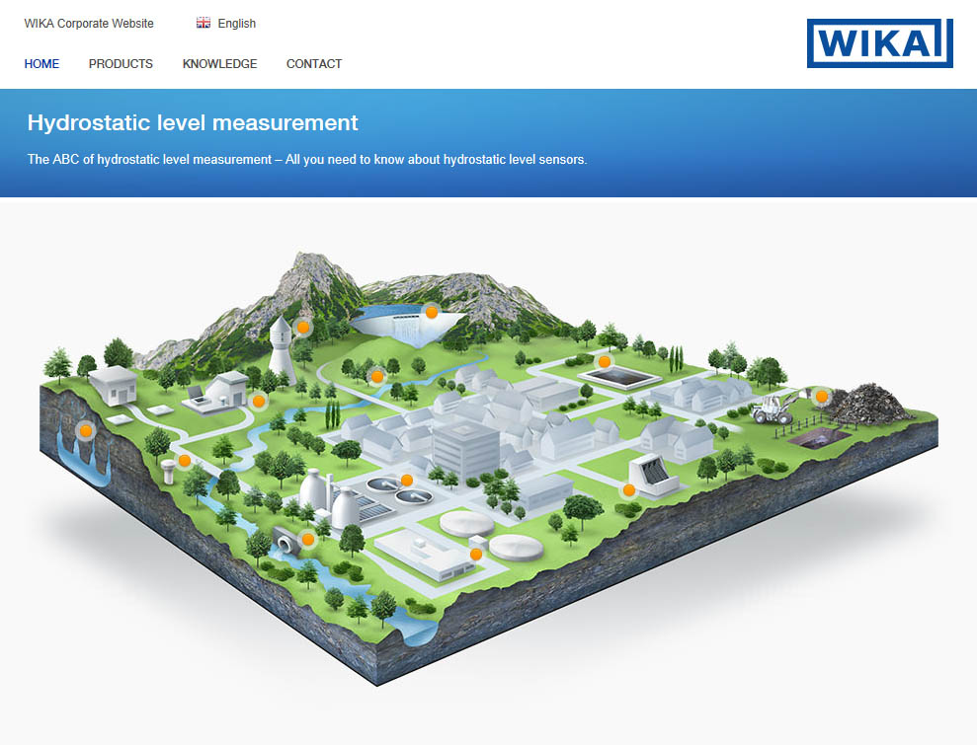

Edited by:
WIKA Alexander Wiegand SE & Co. KG
André Habel Nunes
Marketing Services
Alexander-Wiegand-Straße 30
63911 Klingenberg/Germany
Tel. +49 9372 132-8010
Fax: +49 9372 132-8008010
andre.habel-nunes@wika.com
www.wika.com

WIKA press release 03/2014

